Capstone Project Abstract

**2nd October 2024**

**Group Members**

Saransh Kotha - sr384758@dal.ca

Rutvik Vengurlekar – rt762740@dal.ca

Rowena Sagaria – rowenasagaria@dal.ca

**Introduction**

The hunt for used goods like household goods, accessories, furniture, second-hand cars, and electronic gadgets is becoming easier yet overwhelmingly fragmented with more e-commerce websites surfacing on the internet. Accessing data about such purchases is a time-consuming, less filterable, and terribly annoying task migrants and immigrants in Canada would have to put in. Most of these listings might appear under different platforms, like Facebook Marketplace, Kijiji, Clutch, or Autotrader, each would need to be navigated separately for their search, a thing which is hugely time-consuming and frustrating.

**Problem Definition**

As of now, there does not exist any platform where users could locate listings from these different platforms all in one place. Such a fragmented approach may also result in missed opportunities and confusion for those people who want to find what they need as fast and easily as possible.

**Proposed Idea**

To resolve this, we will create a website that will be a source hub for second-hand product listings on different platforms. The listings will be made available into one easy-to-use platform with more filtering options. We will make things so much easier with our website—gathering all these listings together in a user-friendly platform where the user can filter the product based on category, price range, location, condition, and type.

The same will not only save time but also facilitate the customers with more variety of products under one roof. Listings on our website will be updated through web scraping and integrations with APIs. Advanced searching and comparing capabilities will be provided to our users, making comparisons among different platform products quick and smooth. Users can even set up alerts with their set of items, making the experience more personalized and tailored to their preferences. This will be extremely helpful for international students, migrants, and immigrants who have been oblivious to the landscape of marketplaces in Canada. Our platform reduces the curve, making it easier for them to go ahead and find high-quality, affordable used products without having to go through the hassle.

**Hypotheses of Design**

* Customers would prefer to stay with one site rather than hopping around through multiple listings.
* Filters have the potential to enable quicker and easier searching based on specific prices, locations, or conditions of the product.
* The platform will enhance users' satisfaction, making them efficient in finding what they need on time.

**User End Approach**

We will initiate interviews and conduct questionnaires among our target audience: students, migrants, and new immigrants in Canada. Later, we will conduct usability testing with the website prototype on the test participants to complete the circle. The feedback will drive revisions toward a final product that meets users' expectations.

**Technology Stack**

The complete project will be built with web technologies: HTML, CSS, and JavaScript with React. Moreover, powering the backend are Python-based web scraping and API integrations. Product listings will be stored via MySQL, while third-party APIs will compare deals in real time across different platforms. Integration of APIs will allow us to automate the process of listing new products on our website updating it timely. For the prototype, design tools like Adobe XD will be utilized to show and tell what the platform will look and feel like.

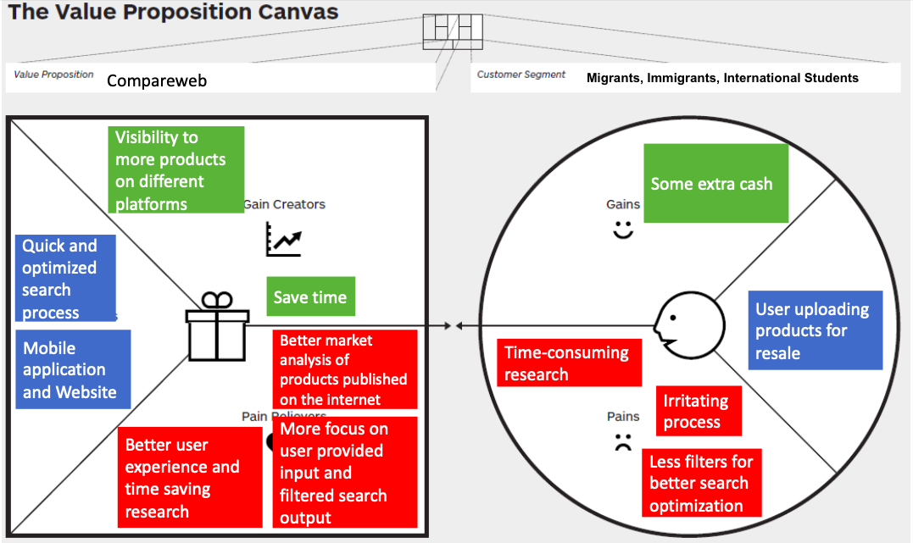

From the value proposition canvas, we would like to address some common misconception about the trade in second-hand economics as shown below:

1. The market for second-hand products is niche.
2. The number of users are limited.

To address the market question, we have researched about some surveys on the Canadian reseller market by PayPal. As per the stats provided,

1. $29B spend in second hand transaction in Canada in 2016.[1][2]
2. A third of Canadians purchase second-hand goods more than once a month (31%) – with three in four (73%) doing so to make their money go further.[1][2]
3. Almost half (42%) of Gen Z Canadians report buying used goods more than once a month. Almost 82% Canadians who participate in some form of second-hand transactions (monetary and non-monetary).[1][2]
4. Half of Canadians (50%) say they have found reselling their unwanted items is a good supplement to their primary income [1][2]

It is worth noting that as the inflation is climbing Y-O-Y basis, more people are finding reselling their used products a good option, giving steady surge to the second-hand economy.

**References:**

1. Global News. (2017, February 22). Nearly two billion items changed hands in 2016 as second-hand economy continues to grow.

<https://globalnews.ca/news/3308108/nearly-two-billion-items-changed-hands-in-2016-as-second-hand-economy-continues-to-grow/>

1. PayPal Canada. (2023, June 13). PayPal survey reveals Canadians could make an estimated $571 on average from pre-loved items in their home.

<https://www.newswire.ca/news-releases/paypal-survey-reveals-canadians-could-make-an-estimated-571-on-average-from-pre-loved-items-in-their-home-804969086.html>